Alteration of Gateway Determination

Planning proposal: PP_2016_PARRA_013_00 for land at corner
of Parramatta Road, Albert Street, Victoria Street and the Railway Line, Granville.

I, the Director, Sydney Region West, at the Department of Planning and Environment, as delegate of the Greater Sydney Commission, have determined under section 3.34(7) of the Environmental Planning and Assessment Act 1979 to alter the Gateway determination dated 15 June 2016 (as since altered) for the proposed amendment to the Parramatta Local Environmental Plan 2011 as follows:

- Delete:

“condition 9”

and replace with:

a new condition 9 “The timeframe for completing the LEP is by 22 June 2018”

Dated 22nd day of March 2018.
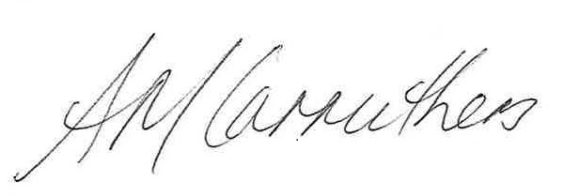
Ann-Maree Carruthers
Director, Sydney Region West
Planning Services
Department of Planning and Environment

Delegate of the Greater Sydney Commission

